**LAB CYCLE - 1**

**EXPERIMENT NO: 1 DATE:**

FAMILIARISATION WITH COMPUTER HARDWARE

**AIM:** Basic components of computer hardware

# DESCRIPTION

Computer hardware is a collective term used to describe any of the physical components of an analog or digital [computer](https://www.techtarget.com/searchwindowsserver/definition/computer). The term hardware distinguishes the tangible aspects of a computing device from [software,](https://www.techtarget.com/searchapparchitecture/definition/software) which consists of written, machine-readable instructions or [programs](https://www.techtarget.com/searchsoftwarequality/definition/program) that tell physical components what to do and when to execute the instructions. Hardware and software are complementary. A computing device can function efficiently and produce useful output only when both hardware and software work together appropriately. Computer hardware can be categorized as being either internal or external components.

Components of a computer system are the primary elements which make the functioning of an electronic device smooth and faster. Computer systems consist of three components as shown in below image: Central Processing Unit, Input devices and Output devices. Input devices provide data input to processor, which processes data and generates useful 4information that’s displayed to the user through output devices. This is stored in computer’s memory.

The operations of computer components are given below:

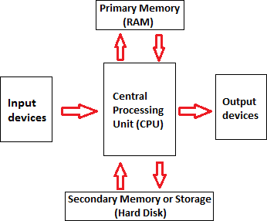

Figure 1. Components of computers

1. **Inputting:** It is the process of entering raw data, instructions and information into the computer. It is performed with the help of input devices.
2. **Storing:** The computer has primary memory and secondary storage to store data and instructions. It stores the data before sending it to CPU for processing and also stores the processed data before displaying it as output.
3. **Processing:** It is the process of converting the raw data into useful information. This process is performed by the CPU of the computer. It takes the raw data from storage, processes it and then sends back the processed data to storage.
4. **Outputting:** It is the process of presenting the processed data through output devices like monitor, printer and speakers.
5. **Controlling:** This operation is performed by the control unit that is part of CPU. The control unit ensures that all basic operations are executed in a right manner and sequence.

Some of the popular input devices are:

* 1. [Keyboard](https://www.javatpoint.com/input-devices#Keyboard)
  2. [Mouse](https://www.javatpoint.com/input-devices#Mouse)
  3. [Scanner](https://www.javatpoint.com/input-devices#Scanner)
  4. [Joystick](https://www.javatpoint.com/input-devices#Joystick)
  5. [Light Pen](https://www.javatpoint.com/input-devices#LightPen)
  6. [Touch Pad](https://www.javatpoint.com/input-devices#TouchPad)
  7. [Remote](https://www.javatpoint.com/input-devices#Remote)
  8. [Touch screen](https://www.javatpoint.com/input-devices#TouchScreen)
  9. [VR](https://www.javatpoint.com/input-devices#VR)
  10. [Webcam](https://www.javatpoint.com/input-devices#Webcam)
  11. [Biometric Devices](https://www.javatpoint.com/input-devices#BiometricDevices)

# Output Devices

The output device displays the result of the processing of raw data that is entered in the computer through an input device. There are a number of output devices that display output in different ways such as text, images, hard copies, and audio or video.

Some of the popular output devices are:

1. Monitor
   * CRT Monitor
   * LCD Monitor
   * LED Monitor
   * Plasma Monitor
2. Printer
3. Projector

# Central Processing Unit (CPU)

A Central Processing Unit is also called a processor, central processor, or microprocessor. It carries out all the important functions of a computer. It receives instructions from both the hardware and active software and produces output accordingly. It stores all important programs like operating systems and application software. CPU also helps Input and output devices to communicate with each other. Owing to these features of CPU, it is often referred to as the brain of the computer.

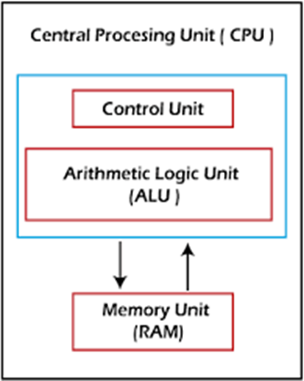

Figure 2. Parts of CPU

# COMPUTER HARDWARE

Hardware, which is abbreviated as HW, refers to all physical components of a computer system, including the devices connected to it. You cannot create a computer or use software without using hardware. The screen on which you are reading this information is also a hardware. Some of the commonly used hardware in your computer are described below:

1. Motherboard
2. Monitor
3. Keyboard
4. Mouse

**MOTHERBOARD**

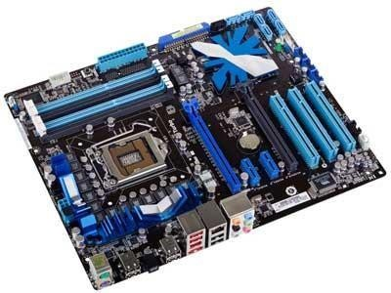The motherboard is generally a thin circuit board that holds together almost all parts of a computer except input and output devices. All crucial hardware like CPU, memory, hard drive, and ports for input and output devices are located on the motherboard. It is the biggest circuit board in a computer chassis. It allocates power to all hardware located on it and enables them to communicate with each other. It is meant to hold the computer's microprocessor chip and let other components connect to it.

Figure 3. Motherboard

# COMPONENTS OF MOTHERBOARD

**CPU Slot:** It is provided to install the CPU. It is a link between a microprocessor and a motherboard. It facilitates the use of CPU and prevents the damage when it is installed or removed. Furthermore, it is provided with a lock to prevent CPU movement and a heat sink to dissipate the extra heat.

**RAM Slot:** It is a memory slot or socket provided in the motherboard to insert or install the RAM (Random Access Memory). There can be two or more memory slots in a computer.

**Expansion Slot:** It is also called the bus slot or expansion port. It is a connection or port on the motherboard, which provides an installation point to connect a hardware expansion card, for example, you can purchase a video expansion card and install it into the expansion slot and then can install a new video card in the computer. Some of the common expansion slots in a computer are AGP, AMR, CNR, PCI, etc.

**Capacitor:** It is made of two conductive plates, and a thin insulator sandwiched between them. These parts are wrapped in a plastic container.

**Inductor (Coil):** It is an electromagnetic coil made of a conducting wire wrapped around an iron core. It acts as an inductor or electromagnet to store magnetic energy.

**Northbridge:** It is an integrated circuit that allows communications between the CPU interface, AGP, and memory. Furthermore, it also allows the southbridge chip to communicate with the RAM, CPU, and graphics controller.

**USB Port:** It allows you to connect hardware devices like mouse, keyboard to your computer.

**PCI Slot:** It stands for Peripheral Component Interconnect slot. It allows you to connect the PCI devices like modems, network hardware, sound, and video cards.

**AGP Slot:** It stands for Accelerated Graphics Port. It provides the slot to connect graphics cards. **Heat Sink:** It absorbs and disperses the heat generated in the computer processor.

**Power Connector:** It is designed to supply power to the motherboard.

**CMOS battery:** It stands for complementary metal-oxide-semiconductor. It is a memory that stores the BIOS settings such as time, date, and hardware settings.

# RAM MODULE

RAM stands for Random Access Memory. It is also called the main memory. RAM is a temporary data storage device in computers and other devices. SRAM,DRAM SDRAM, DDR etc are the various types of RAM available.

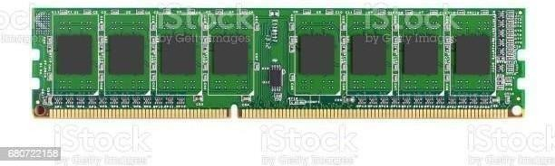A memory module or RAM stick is a narrow printed circuit board that holds memory chips (RAM chips).

Figure 4.1. Ram module

SRAM (static RAM) is random access memory ([RAM](https://www.techtarget.com/searchstorage/definition/RAM-random-access-memory)) that retains data bits in its memory as long as power is being supplied. You can lose data if your SRAM is not powered. SRAM does not offer to refresh programs. SRAM has a low storage capacity(about 1MB).

Dynamic random access memory (DRAM) is a type of semiconductor memory that is typically used for the data or program code needed by a computer processor to function. The advantage of a DRAM is it only requires a single transistor compared to around six in a typical static RAM, SRAM memory cell. The costs of DRAM are much lower than those for SRAM, and they are able to provide much higher levels of memory density(about 1GB).

SDRAM (synchronous DRAM) is a generic name for various kinds of DRAM that are synchronized with the clock speed that the microprocessor is optimized for. That is, same external clock pulse can be used to operate both SRAM and processor. This tends to increase the number of instructions that the processor can perform in a given time.

DDR Stands for "Double Data Rate." It is an advanced version of SDRAM, DDR- SDRAM can transfer data twice as fast as regular SDRAM chips. This is because DDR memory can send and receive signals twice per clock cycle.DDR operates about

2.5 V and DDR2 averages about 1.8 V, with DDR3 the voltage is reduced to 1.5 V.

DDR3 has transfer rates between 800MT/s and 1600MT/s.DDR4 is the latest generation of DDR. It has the lowest operating voltage of 1.2 V and has higher transfer rates than previous generations.DDR5 launch speeds delivery nearly double the bandwidth of DDR4.

# DAUGHTER CARDS

A daughterboard ( daughter card ) is a type of circuit board that plugs in or is attached to the motherboard or similar expansion card to extend its features and services.

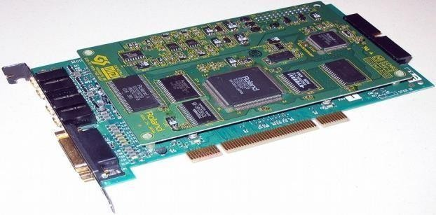

Figure 4.2. Daughter cards

A daughterboard is connected directly to the motherboard. Like a motherboard, a daughterboard has sockets, pins, plugs and connectors to be attached to other boards. Today, these boards are not found or used in desktop computers. They were replaced with ISA card, PCI card and onboard options. With the rise of connective USB ports and other technology, it has become less necessary to upgrade devices with daughtercards or daughterboards.

**BUS SLOT**

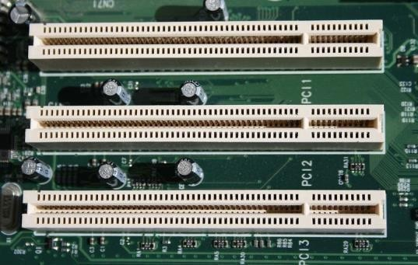An expansion slot is a socket on the motherboard that is used to insert an expansion card , which provides additional features to a computer such as video, sound, advanced graphics, Ethernet or memory.

Figure 4.3. Bus slot

PATA stands for Parallel Advanced Technology Attachment and SATA stands for Serial Advanced Technology Attachment both are two bus interfaces used for connecting secondary storage devices like hard disks, optical drives.

Serial refers to the fact that data is sent one bit at a time down a single connection in each direction. There’s a separate connection for data going in to and out of the device. Parallel refers to the fact that data is sent 16 bits at a time through a single 16- bit connection, which is used for data traveling in both directions.

**SMPS (Switched Mode Power Supply)**

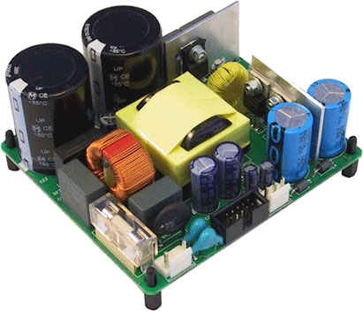A **switched-mode power supply (SMPS)** is an electronic circuit that converts power using switching devices that are turned on and off at high frequencies, and storage components such as inductors or capacitors to supply power when the switching device is in its non-conduction state. Switching power supplies have high efficiency and are widely used in a variety of electronic equipment, including computers and other sensitive equipment requiring stable and efficient power supply. A switched-mode power supply is also known as a switch-mode power supply or switching-mode power supply.

Figure 4.4. SMPS

# INTERNAL STORAGE DEVICE

Internal storage devices are components of a computer system that provide non-volatile storage for files, applications, and the operating system. Internal storage devices are typically housed within the computer's chassis or connected directly to the motherboard.

Some common types of internal storage devices include:

* **Hard disk drives (HDDs)**: These are traditional storage devices that use spinning disks to store data. HDDs are known for their high storage capacities and relatively low cost per GB.
* **Solid-state drives (SSDs**): These are newer storage devices that use flash memory to store data. SSDs are known for their faster read and write speeds compared to HDDs, as well as their reliability and durability.

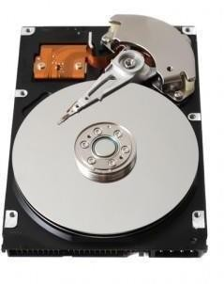 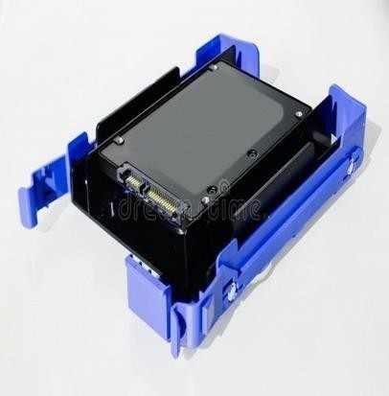

Figure 4.5. HDD Figure4.6. SSD

**Result:** Familiarised with computer hardware.